Week 5

5a: Reinforcement Learning

Overview:
The topic for this week is Reinforcement Learning (RL). We will see how reinforcement learning tasks can be formally defined, compare different models of optimality, and discuss the need for exploration and the problem of delayed rewards. We will present a number of RL algorithms including Temporal Difference learning (TD-learning), Q-learning, policy gradients, actor-critic. We will see how RL can be applied to games like backgammon, and how deep Q-learning or A3C can learn to play Atari games from raw pixels.

Weekly learning outcomes
By the end of this week, you will be able to:
- explain the difference between supervised learning, reinforcement learning, and unsupervised learning
- describe the formal definition of a reinforcement learning task
- identify different models of optimality
- explain the need for exploration in reinforcement learning
- describe reinforcement learning algorithms, including TD-learning, Q-learning, policy gradients, and actor-critic
- apply Q-learning to simple tasks.

Reinforcement Learning
We have previously discussed supervised learning, where pairs of inputs and target outputs are provided and the system must learn to predict the correct output for each input.
There are many situations where we instead want to train a system to perform certain actions in an environment, in order to maximise a reward function. These situations include, for example, playing a video game, allocating mobile phone channels or other resources dynamically, drivin a car or flying a helicopter.
Supervised learning can sometimes be used for this purpose, if we construct a training set of situation-action pairs (for example, a database of game positions and the move chosen by a human expert, or sensor readings from a motor car and the steering direction chosen by a human driver). This process is sometimes called Behavioural Cloning.
However, it is often better if the system can learn by purely by self-play, without the need for training data from a human expert.

Reinforcement Learning Framework
Reinforcement Learning (RL) can be formalised in terms of an Agent interacting with its Environment.
The Environment includes a set of states and a set of actions. At each time step , the agent is in some state . It must choose an action , whereupon it goes into state and receives reward
The Agent chooses its actions according to some policy .
The aim of Reinforcement Learning is to find an optimal policy which maximises the cumulative reward.
In some cases, the Environment may be probabilistic or stochastic − meaning that the transitions and/or rewards are not fully determined, but instead occur randomly according to some probability distribution:

The Agent can also employ a probabilistic policy, with its actions chosen according to a probability distribution:

reinforcement learning video (4:42)

Probabilistic Policies
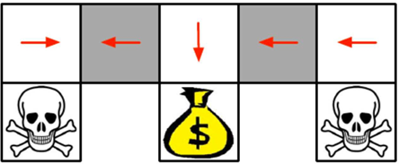

Consider, for example, a situation in which the Agent is able to observe that it is in one of the grey squares, but is not able to determine which grey square it is in. In this case, the policy of moving left or right with equal probability from the grey square will perform better than any deterministic policy.
In two-player games like rock-paper-scissors, a random strategy is also required in order to make agent choices unpredictable to the opponent.

Models of Optimality
What exactly do we mean when we say that an RL Agent should choose a policy which maximises its future rewards?
The old saying "a fast nickel is worth a slow dime" reminds us that people often prefer to receive a smaller reward sooner instead of a larger reward later. Economists use surveys to gauge people's preferences in this regard: "Would you prefer ten dollars today, or 15 dollars next week? How about $50 today compared to $100 next year?" Responses to these surveys can be used to estimate a number between 0 and 1 that is chosen such that one dollar in the current timestep is considered equally desirable with γ dollars in the next timestep. In Reinforcement Learning, this number is called the discount factor and is used to define the infinite discounted reward, which can be compared with average reward and finite horizon reward.

We normally try to maximise the infinite discounted reward, because it is easier to analyse theoretically and also works well in practice.
The finite horizon reward is easy to compute, but may lead to bad decisions by failing to take into account rewards which are just over the horizon.
Average reward is hard to deal with because we cannot sensibly choose between a small reward soon and a large reward very far in the future − for example, 100 dollars today compared with a million dollars, 50 years from now.

Comparing Models of Optimality
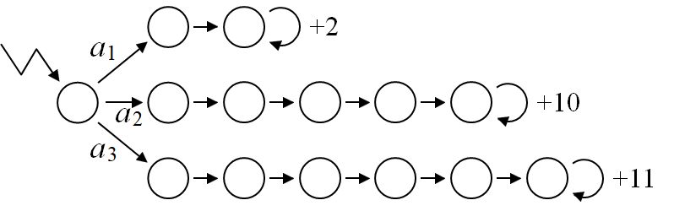
This environment illustrates how the choice of action may depend on the model of optimality.
- An agent trying to maximise the finite horizon reword with would prefer action because it is the only action which will gain any reward within the first four time steps.
- An agent maximising average reward will prefer action because, after the first few time steps, it will be getting a reward of every timestep which is larger than for an agent who chose action .
- An agent maximising infinite discounted reward with will prefer action . One way to see this is as follows: Consider Agent choosing action , compared to Agent choosing action .
- The reward of 11 received by in timestep 7 would be equivalent to 9.9 in timestep 6 and therefore slightly less than the $10 received by in timestep 6.
- By the same logic, the $10 received by in timestep n is always slightly more valuable than the $11 received by in timestep .

Optional video - reinforcement learning frameworks (9:53)
Discounted future reward
infinite discounted future reward
Finite is difficult to deal with theoretically and often leads to perverse outcomes

Value Function
Every policy π determines a Value Function where is the average discounted reward received by an agent who begins in state and chooses its actions according to policy
For small environments, we can compute the value function using simultaneous equations. For larger environments, we need a way of learning it, through experience.

Summing an infinite series (5:15)
If , the value of the last node in the middle row of the above diagram is . The value of the last node in the lowest row is . The value of the second last node in the lower row is 99, which can be obtained from the value of the last node either by subtracting 11 or multiplying by .

Value Function Example
This image shows the value function in a grid world environment, where is the policy of choosing between available actions uniformly randomly.

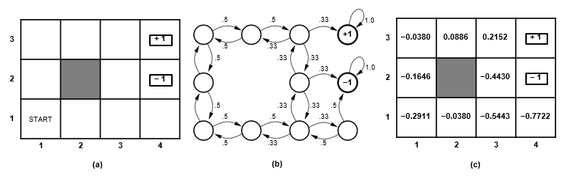
Exploration and Delayed Reinforcement
I was born to try ...
But you've got to make choices
Be wrong or right
Sometimes you've got to sacrifice the things you like.
− Delta Goodrem

Multi-Armed Bandit Problem

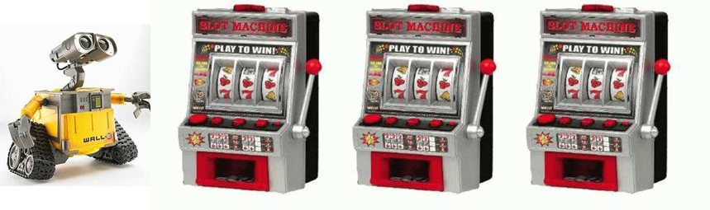
Exploration / Exploitation Tradeoff
After pulling the levers a few times and observing the rewards received, it makes sense that most of the time we should choose the lever (action) which we think will give the highest expected reward, based on previous observations.
However, in order to ensure convergence to the optimal strategy, we must occasionally choose something different from our preferred action. Perhaps the simplest way to achieve this is known as an epsilon-greedy strategy , where with probability we choose what we think is the best action, and with probability (typically, 5%) we choose a random action. More sophisticated strategies also exist such as Thompson Sampling, Upper Confidence Bound (UCB) algorithms, or choosing from a Softmax (Boltzmann) distribution based on the average reward so far observed for each action.

You may have noticed that we make the same kind of judgements about exploration versus exploitation in everyday situations. Should you eat at the old restaurant you have visited many times, or should you try the newly opened restaurant across the street which might be worse but might be much better?

Optional Video (7.27):

Delayed Reinforcement
You may have noticed that we make the same kind of judgements about exploration versus exploitation in everyday situations. Should you eat at the old restaurant you have visited many times, or should you try the newly opened restaurant across the street which might be worse but might be much better?

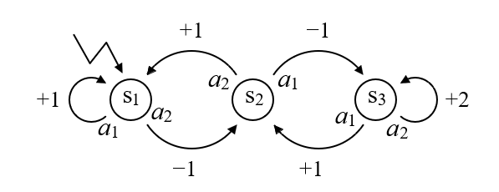

Recall that every policy π determines a Value Function where is the expected discounted reward received by an agent who begins in state and chooses its actions according to policy .
If is optimal, then is the maximum (expected) discounted reward obtainable from state . Knowing this optimal value function can help to determine the optimal policy.

Computing the Value Function
Let and consider the policy We have

For this example, the policy π shown above must be the optimal policy, because the value function for states and under any other policy would not be more than 10. Therefore, the optimal value function is

If we were given this value function , we could use it to determine the optimal policy provided we also know the reward function and the transfer function . This information is sometimes called the "World Model".
The optimal policy is
.

Optional video: computing the value function (7:04)
Sometimes we have to sacrifice short term gain in the pursuit of long term interest maximisation.

Q-Function
The Q-function is a more sophisticated version of the value function which enables an agent to act optimally without needing to know the World Model.
For any policy , the Q-function is the expected discounted reward received by an agent who begins in state s, first performs action a and then follows policy π for all subsequent timesteps.
If is optimal, then is the maximum (expected) discounted reward obtainable from , if the agent is forced to take action in the first timestep but can act optimally thereafter.
If the optimal Q-function is known, then the optimal policy is given by

The Q-function for the environment shown above can be computed as follows:

TD-Learning and Q-Learning
Reinforcement Learning algorithms can generally be grouped into three classes:
- Value function learning, including TD-Learning and Q-Learning
- Policy learning, including policy gradients and evolution strategies
- Actor-Critic, which is a combination of value function and policy learning

Value Function Learning
Recall that if is optimal, then is the maximum (expected) discounted reward obtainable from state , and is the maximum (expected) discounted reward obtainable from , if the agent is forced to take action in the first timestep but can act optimally thereafter.
The idea behind value function learning is that the agent retains its own estimate or of the "true" value function or . This estimate might be quite inaccurate to start with, but it gets iteratively improved over time so that it more closely approximates the true value. This process is sometimes called "Bootstrapping".

Temporal Difference Learning
Let’s first assume that and are deterministic. Then the (true) value of the current state should be equal to the immediate reward plus the discounted value of the next state

We can turn this into an update rule for the estimated value:

If and are stochastic (multi-valued), it is not safe to simply replace with the expression on the right hand side. Instead, we move its value fractionally in this direction, proportional to a learning rate .

Q-Learning
Q-learning is similar to TD-learning except that the Q-function depends on a state, action pair instead of just a state.
For a deterministic environment, and are related by

The last equation suggests that we can iteratively update our estimate by

Optional Video - temporal difference Learning & Q learning (8:21):

Theoretical Results and Generalisation (3:24)
It can be proved that TD-learning and Q-learning will eventually converge to the optimal policy, for any deterministic Markov decision process, assuming an appropriately randomised strategy (Sutton, 1988; Watkins & Dayan 1992; Dayan & Sejnowski, 1994).
However, these results rely on the assumption that every state will be visited many times. For small environments with a limited number of states and actions, this assumption is reasonable. For more challenging environments, the number of states can be exponentially large and it may be impractical to assume that every state will be visited even once. In these situations, we need to rely on a model such as a neural network that is able to generalise to estimate the value of new states based on their similarity with states that have previously been encountered.

Computer Game Playing
Suppose we want to write a computer program to play a game like backgammon, chess, checkers or Go. This can be done using a tree search algorithm (expectimax, MCTS, or minimax with alpha-beta pruning). But we need:
- an scheme for encoding any board position as a set of numbers, and
- a way to train a neural network or other learning system to compute a board evaluation, based on those numbers.

Backgammon
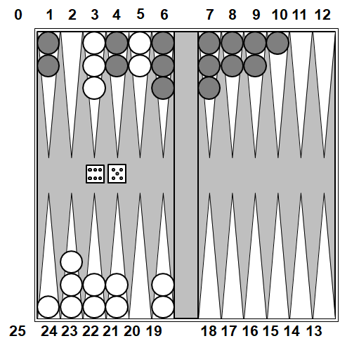

One of the first practical applications of TD-learning (Tesauro, 1992) was to play the game of backgammon, which involves rolling dice and moving pieces around a board with 24 "points". In the above diagram, the white player is moving their pieces clockwise toward the bottom left quadrant while the black player is moving their pieces anti-clockwise toward the upper left quadrant. When a player gets all of their pieces into the last quadrant, they can use the dice rolls to move pieces off the board. The first player to get all of their pieces off the board is the winner.
If a player has only one piece on a point (such as point 10 or 24 above) and the other player moves a piece to that point, the original piece is sent back to the "bar" and must start again from the beginning. If a player has two or more pieces on a point, the other player is not allowed to move a piece to that point. We see in the above position that the black player has multiple pieces on points 1, 4, 6, 7, 8, 9 so that the white player will not be able to move their pieces on points 3 or 5 unless they roll either 2, 5 or 6.

TD-Gammon Neural Network
TD-Gammon used a 2-layer neural network with 196 inputs, 20 hidden nodes and 1 output. The inputs are arranged as follows:
- 4 units × 2 players × 24 points
- 2 units for pieces on the bar
- 2 units for pieces off the board
Four inputs are assigned to each colour and each point, with a 1-hot encoding used to specify one, two or three pieces and the fourth input scaled in proportion to the number of pieces if there are more than three. Additional inputs specify the number of pieces of each colour which are on the bar, or off the board.
For any encoded board state, the network produces an output between 0 and 1 which is interpreted as its estimate of the probability of winning from that state.
At each timestep, the dice are rolled, the network considers all possible legal moves and computes the “next board position” that would result from each move. These are converted to the appropriate input format, fed to the network, and the one which produces the largest output is chosen.
The network can be trained by backpropagation using this formula

where are the weights in the network, is the learning rate, is the actual output of the network, and is the target value.
The question is: How do we determine the target value ? In other words, how do we know what the value of the current position “should” have been? Alternatively, how do we find a better estimate for the current position?

How to choose the Target value
One approach is to have a human expert play many games and build a database of positions, dice rolls and chosen moves, similar to what was done for the ALVINN autonomous driving system we discussed in Week 1. The network could then be trained to increase the evaluation of each move chosen by the human expert and decrease that of other moves which were available but did not get chosen.
Another approach is for the network to learn from self-play by TD-learning, effectively using the evaluation of subsequent positions in the game to refine the evaluation of earlier positions.
Other methods such as TD-Root, TD-Leaf, MCTS and TreeStrap (Veness et al., 2009) combine learning with tree search. These are important for deterministic games like chess or Go, but less important for a stochastic game like backgammon because the randomness of the dice rolls limits the benefit of deep lookahead.
For backgammon, the agent receives just a single reward at the end of each game, which we can consider as the final value (typically, +1 for a win or -1 for a loss). We then have a sequence of game positions, each with its own (estimated) value:

In this context, TD-learning simplifies and becomes equivalent to using the value of the next state as the training value for the current state . A fancier version, called , uses a weighted average over future estimates as the training value for , where:

The parameter between 0 and 1 serves as a kind of discount factor, but is different to the usual discount factor (which can be equal to 1 in the case of TD-Gammon, because we do not care when we get the reward so long as we get it).

TD-Gammon
Tesauro trained two networks − one using Expert Preferences (EP), the other by TD-learning (TD). The TD-network outperformed the EP-network, and with modifications such as 3-step lookahead (expectimax) and additional hand-crafted input features, became the best backgammon player in the world in 1995.

Optional video computer game playing (17:17)

References
- Sutton, R.S. 1988. Learning to predict by the methods of temporal differences, Machine Learning, 3(1), 9-44.
- Watkins, C.J. 1989. Learning from Delayed Rewards, PhD Thesis, University of Cambridge.
- Watkins, C.J., & Dayan, P. 1992. Q-learning, Machine Learning, 8(3-4), 279-292.
- Dayan, P., & Sejnowski, T.J. 1994. TD (λ) converges with probability 1, Machine Learning, 14(3), 295-301.
- Tesauro, G., 1992. Practical issues in temporal difference learning. Machine Learning, 8(3), 257-277.
- Veness, J., Silver, D., Uther, W. & Blair, A., 2009. Bootstrapping from game tree search, Advances in Neural Information Processing Systems (NIPS 22), 1937-1945.

5b: Policy Learning & Deep RL

Policy Learning
Policy learning algorithms do not use a value function but instead operate directly on the policy, chosen from a family of policies determined by parameters .
Typically, is a neural network with weights which takes a state s as input and produces action a as output, which may be either continuous or discrete. If there is a discrete choice of actions, the network has one output for each possible action and uses Softmax to determine the conditional probability of performing action in state .
For episodic domains like Backgammon, we do not need a discount factor, and the "fitness" of policy can be taken as the Value function of the initial states under this policy, which is the expected (or average) total reward received in each game by an agent using policy .

Policy Learning algorithms include Policy Gradients, which use gradient descent to modify the parameters , and Evolution Strategies, which make random changes to and keep only those updates that are seen to increase the reward.

Optional video ()

Evolution Strategies
We will not go into details of evolutionary strategies in this course, but this video explains the basic idea using a simple example. Further details can be found in (Blair & Sklar, 1999) and (Salimans, 2017).

Optional video ()

Policy Gradients
Let us first consider episodic games where the reward is received only at the end of the episode. The agent takes a sequence of actions

At the end it receives a reward . We don't know which actions contributed the most, so we just reward all of them equally. If is high (low), we change the parameters to make the agent more (less) likely to take the same actions in the same situations. In other words, we want to increase (decrease)

If for a win and −1 for a loss, we can simply multiply the log probability by . Differentials can be calculated using the gradient

The gradient of the log probability can be calculated nicely using Softmax. If takes some other range of values, we can replace it with where is a fixed value, called the baseline.

The REINFORCE Algorithm
We then get the following REINFORCE algorithm (Williams, 1992):
for each trial
run trial and collect states , actions , and reward
for to length(trial)

end
end
This algorithm has successfully been applied, for example, to learn to play the game of Pong from raw image pixels.

Optional video()

Policy Gradients with Incremental Rewards
We wish to extend the framework of Policy Gradients to non-episodic domains where rewards are received incrementally throughout the game (e.g. PacMan, Space Invaders). Every policy determines a distribution on

where prob is the probability that, after starting in state and performing actions, the agent will be in state . We can then define the fitness of policy as

Note: In the case of episodic games, we can take , in which case is simply the expected reward at the end of the game. However, the above equation holds in the non-episodic case as well. The gradient of and are extremely hard to determine, so we ignore them and instead compute the gradient only for the last term .

Optional video ()

The Log Trick

so

The reason for the last equality is this: is the number of times (discounted by ) that we expect to visit state s when using policy . Whenever state is visited, action a will be chosen with probability .

Optional video ()

Actor-Critic
Recall:

For non-episodic games, we cannot easily find a good estimate for . One approach is to consider a family of -functions determined by parameters (different from ) and learn so that approximates , at the same time that the policy itself is also being learned.
This is known as an Actor-Critic approach because the policy determines the action, while the -Function estimates how good the current policy is, and thereby plays the role of a critic.

Actor Critic Algorithm
For each trial
sample from
for each timestep do
sample reward from
sample next state from
sample action from

end
end

References
Blair, A.D., & E. Sklar, 1999. Exploring evolutionary learning in a simulated hockey environment, Congress on Evolutionary Computation (CEC), 197-203.
Salimans, T., Ho, J., Chen, X., Sidor, S., & Sutskever, I., 2017. Evolution strategies as a scalable alternative to reinforcement learning. arXiv:1703.03864.
Williams, R.J., 1992. Simple statistical gradient-following algorithms for connectionist reinforcement learning. Machine Learning, 8(3-4), 229-256.

Deep Reinforcement Learning

Deep Q-Learning for Atari Games
Mnih (2015) demonstrated how Q-learning could be combined with deep CNNs to learn to play Atari games from pixels.
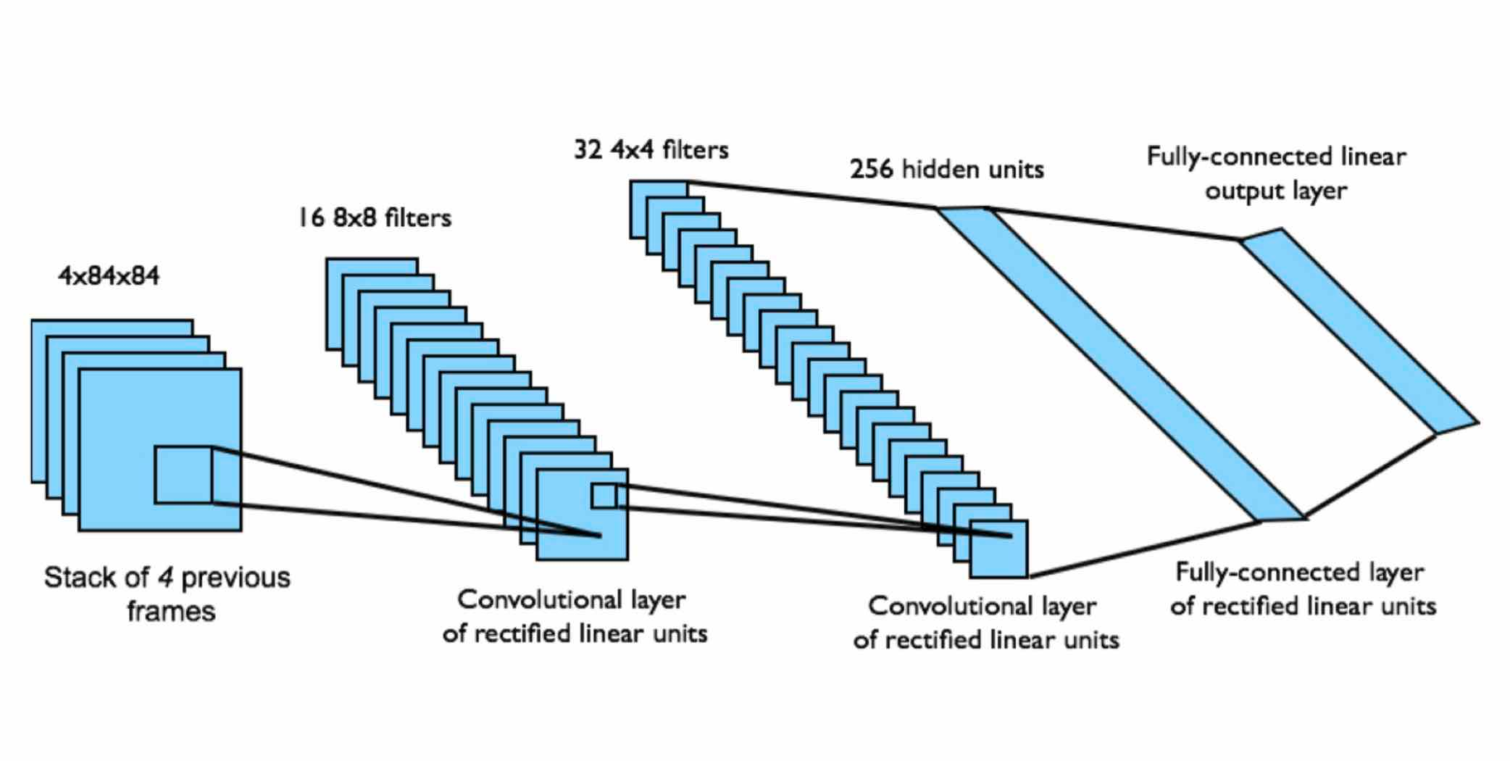
The input state s is a stack of raw pixels from four consecutive frames. The images are converted from 8-bit RGB images at resolution 210×160 pixels to 84×84 greyscale images. The 18 outputs are the Q-values for 18 different combinations of joystick/button positions. The reward is the change in score during the timestep.

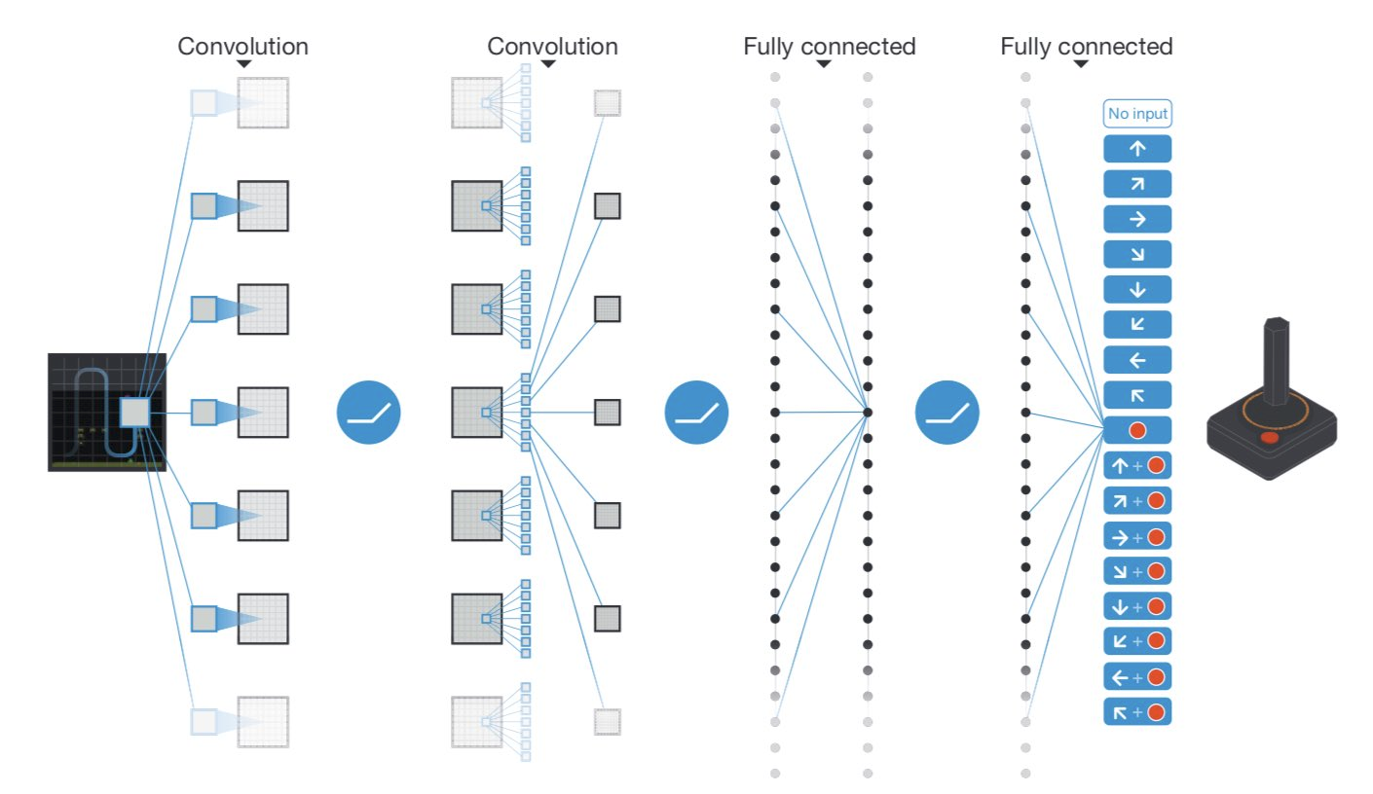
Recall the Q-Learning update rule:

If a lookup table is used to store the Q values for every state and action separately, the algorithm is guaranteed to eventually converge to an optimal policy. But, if the number of states is exponentially large, we must instead use a neural network and adjust the weights according to the Q-Learning update rule, which is equivalent to minimising:

The gradient is applied only to , not to .

Experience Replay
Training of deep neural networks for classification tasks generally requires that each mini-batch should include a variety of different inputs and target outputs. For Atari games, many similar states may occur in succession, often with the same action being selected. We can remove this temporal correlation between samples by storing experiences in a Replay Buffer.
In this scenario, one thread repeatedly plays the game, selecting its actions using an -greedy strategy based on the current Q-values, and builds a database of experiences . Another thread samples asynchronously from this database and applies the Q-learning rule to minimise

This removes temporal correlations by sampling from a variety of game situations in random order, and also makes it easier to parallelise the algorithm on multiple GPUs.

Optional video ()

Prioritised Replay

This ensures the system will concentrate more effort on situations where the value was "surprising" (in the sense of being far away from what was predicted).

Double Q-Learning
If the same weights are used to select actions and to evaluate actions (as well as states) the network may learn a suboptimal strategy due to a kind of "confirmation bias". One way to avoid this is to maintain two sets of weights and , with one used for action selection and the other for evaluation (then swap their roles).
In the context of Deep Q-learning, a simpler approach is to use the current "online" version of w for selection, and an older "target" version for evaluation (Van Hasselt, 2016). We therefore minimise

A new version of is periodically calculated from the distributed values of , and this is broadcast to all processors.

Advantage Function
The Q Function can be written as a sum of the value function plus an advantage function.

represents the advantage (or disadvantage) of taking action in state , compared to taking the action preferred by the current policy . We can learn approximations for these two components separately:

Note that actions can be selected just using , because:

Optional video ()

Advantage Actor-Critic
Recall that in the REINFORCE algorithm, a baseline b could be subtracted from for the purpose of variance reduction.

In the actor-critic framework, is replaced by

We can also subtract a baseline from . This baseline must be independent of the action , but it could be dependent on the state . A good choice of baseline is the value function , in which case the Q function is replaced by the advantage function

Asynchronous Advantage Actor-Critic
The Asynchronous Advantage Actor-Critic or A³C Algorithm combines a policy network , a value function network and an (estimated) Q-function.
- use policy network to choose actions
- learn a parameterised value function by TD-learning
- estimate Q-value by n-step sample:

- update policy by

- update value function by minimising

Optional video()

References
Mnih, V., Kavukcuoglu, K., Silver, D., Rusu, A.A., Veness, J., Bellemare, M.G., Graves, A., et al. 2015. Human-level control through deep reinforcement learning, Nature 518(7540) 529-533.
Schaul, T., Quan, J., Antonoglou, I., & Silver, D., 2015. Prioritized experience replay, arXiv:1511.05952.
Van Hasselt, H., Guez, A., & Silver, D., 2016. Deep reinforcement learning with double Q-learning. In Proceedings of the AAAI Conference on Artificial Intelligence (Vol. 30, No. 1).
Mnih, V., Badia, A. P., Mirza, M., Graves, A., Harley, T., Lillicrap, T., Silver, D., & Kavukcuoglu, K., 2016. Asynchronous methods for deep reinforcement learning. In International Conference on Machine Learning (pp. 1928-1937).

Examples of Deep Reinforcement Learning

Dr Alan Blair discusses a variety of examples of Deep Reinforcement Learning in practice.

Optional Video ()
Mr Alex Long discusses frameworks for understanding Deep Reinforcement Learning with demonstrations.

Optional Video ()

Problems
When , the only thing that matters is the first step.

When

The optimal policy when

2

3
The boundary is

4

5

6

